Solve me First
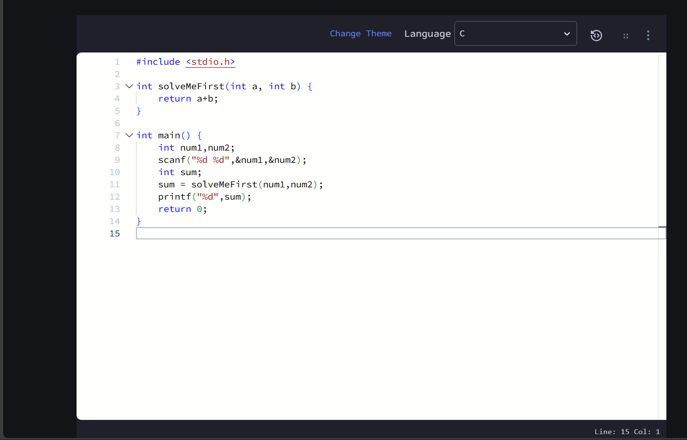
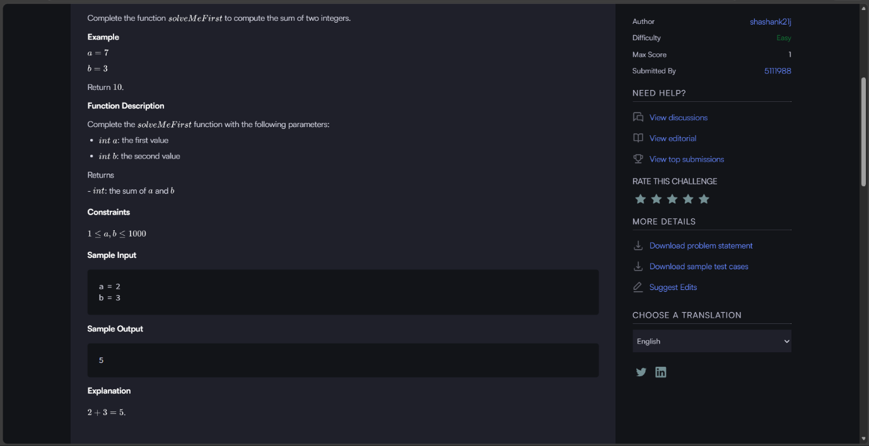
Solve Me First | HackerRank


#include <stdio.h>

int solveMeFirst(int a, int b) {
return a+b;
}

int main() {
int num1,num2;
scanf("%d %d",&num1,&num2);
int sum;
sum = solveMeFirst(num1,num2);
printf("%d",sum);
return 0;
}

